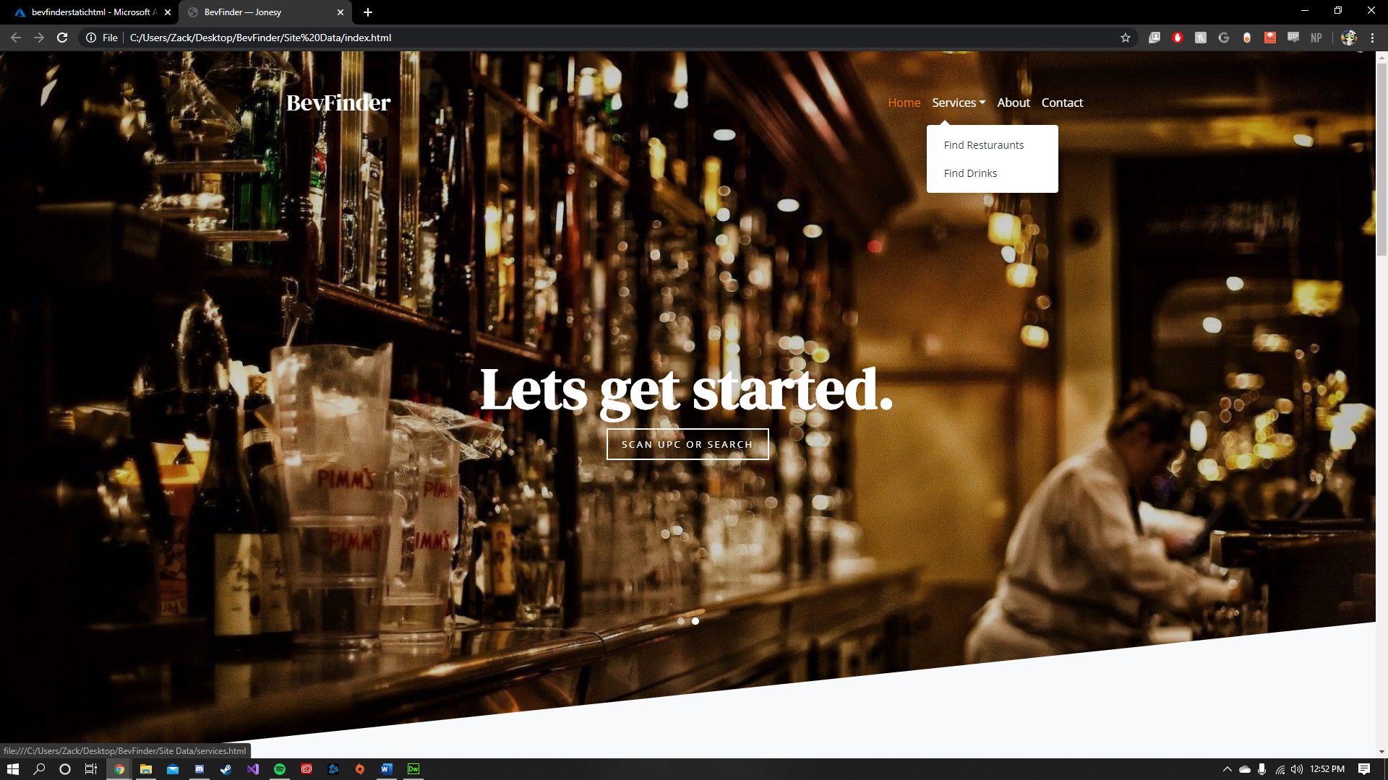

Desktop



Mobile (it was transitioning to the next slide when I took this)

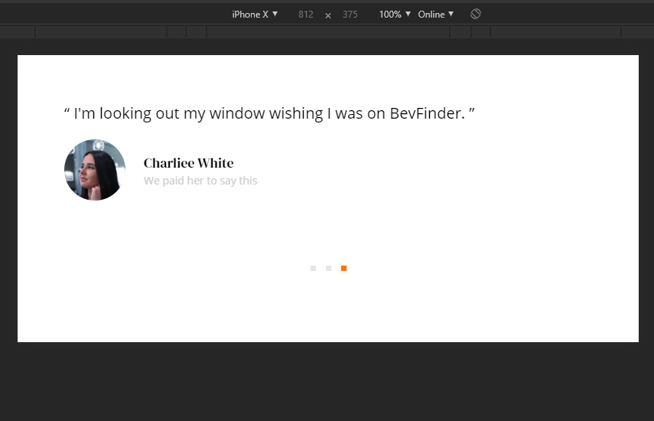

‘Iphone X rotated mobile view. I need to work on sizing for the responsive design portion.

Short answers:

Since I’m more focused on front end development and you told me to focus on that, I’ll answer all of them. I did the math, and if I finish strong (100s from here on out or being able to submit old labs) I’ll graduate. Woo.

* *responsive vs adaptive design*

Most times you’ll want responsive design, however this will depend on what you want to portray to the user.

* *using static or relative sizes?*

You’re pretty much always going to want to use relative Sizes, which is in my sprint to do next week. If you don’t, things get blown up, clipped, and bloated.

* *flow or static positioning for headers/footers/background images...*

Again, this depends on what you want to portray to the user. I happen to like the Flow positioning, but static is easier to work with.

* *using breakpoints*

This also keeps things from getting bloated and clipped. You have to think of all sorts of devices and work accordingly

* *max and min values?*

Usually a good idea, you don’t want your images or items to be clipped or inaccessible.

* *nesting objects (use partial views?)*

Nesting also relies on how you want things to look and react, but for most uses this is very handy and not terribly intrusive to do.

* _design for mobile- or desktop- first

Depends on the product, but given that most people use their phones for EVERYTHING nowadays, I would design for mobile first. However, it’s not terribly hard to design for desktop first and then port to a mobile device.

* *Fonts*

Use system fonts when available to decrease load time, but again, in design, you have a particular look and feel you want to portray. Using Webfonts is not too taxing in reality, and is likely the best option.

* *vector vs bitmaps*

Vector. Always vector. I render my logos for clients in a minimum of 3000 x 3000, if not larger. This will prevent pixilation and is just so so much cleaner and crisper. Be careful of the edges, however. Use a slight layer of opacity to keep it from being jagged.

SPRINT CHART

